**ASSIGNMENT 1**

**SMART HOME AUTOMATION**

|  |  |
| --- | --- |
| **Assignment Date** | 22 September 2022 |
| **Student Name** | Karthika. K |
| **Student Roll Number** | 950619106006 |

**Question1:**

Build a smart home in tinkercad

Use atleast 2 Sensors, Led and Buzzer in a circuit. Simulate in a single code.

**Link:**

http://www.tinkercad.com/things/8nblhN3f2Y

**Program Code:**

float temp;

float vout;

float vout1;

int LED=13;

int gasSensor;

int piezo=7;

void setup()

{

pinMode(A0,INPUT);

pinMode(A1,INPUT);

pinMode(LED,OUTPUT);

pinMode(piezo,OUTPUT);

Serial.begin(9600);

}

void loop()

{vout=analogRead(A1);

vout1=(vout/1023)*5000;

temp=(vout1-500)/10;

gasSensor=analogRead(A0);

if(temp>=80)

{digitalWrite(LED,HIGH);

}else

{digitalWrite(LED,LOW);

}if(gasSensor>=100)

{digitalWrite(piezo,HIGH);

}else

{digitalWrite(piezo,LOW);

}

Serial.print("in Degreec= ");

Serial.print(" ");

Serial.print(temp);

Serial.print("\t");

Serial.print("gassensor=");

Serial.print(" ");

Serial.print(gasSensor);

Serial.println();

delay(1000);

}

**Circuit Design:**

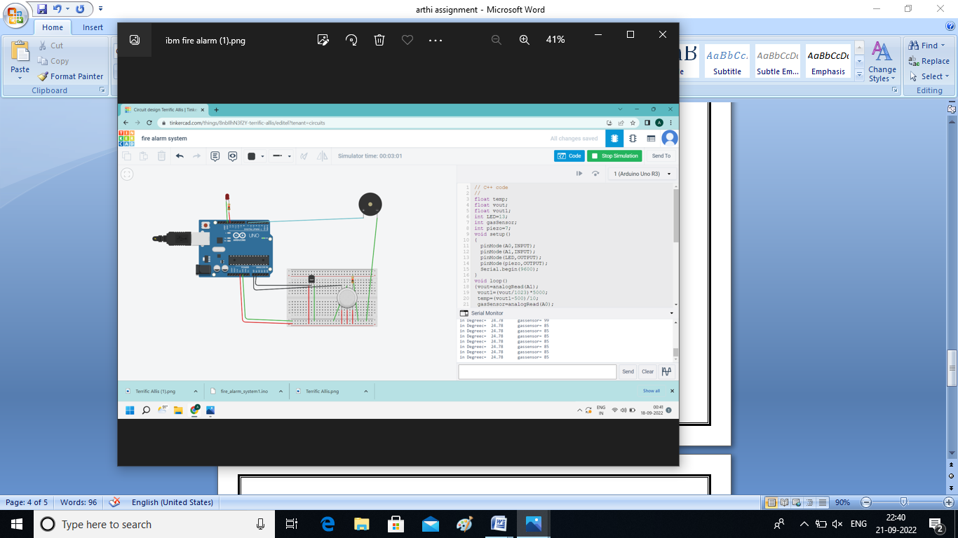

**Output:**

